Project Development Phase
Model Performance Test

Date | 30 September 2026
Team ID | SWTID-2026-3708
Project Name | Streamlining IT Procurement: Automating Standard Laptop Orders with Flow Designer
Maximum Marks
Team Size | 4
Team Leader | A Yashmin
Team Members | Rishwana Parveen S, Deepika Sri M, Pooja S
Submitted by | A Yashmin (Team Leader)

Model Performance Testing:
Project team shall fill the following information in model performance testing template.
S.No. | Parameter | Values | Screenshot
1. | Model Summary | ServiceNow Flow Designer automation "Standard Laptop task" (Application: Global, Run As: System User).  Trigger: Service Catalog. Action: Create Catalog Task for the Requested Item, with Short description and Description "Laptop needs to Configured", Assignment group = Hardware and Approval = Approved.  The flow is attached to the Standard Laptop catalog item under Process Engine, so every approved laptop order automatically creates a configuration task for the Hardware team. | 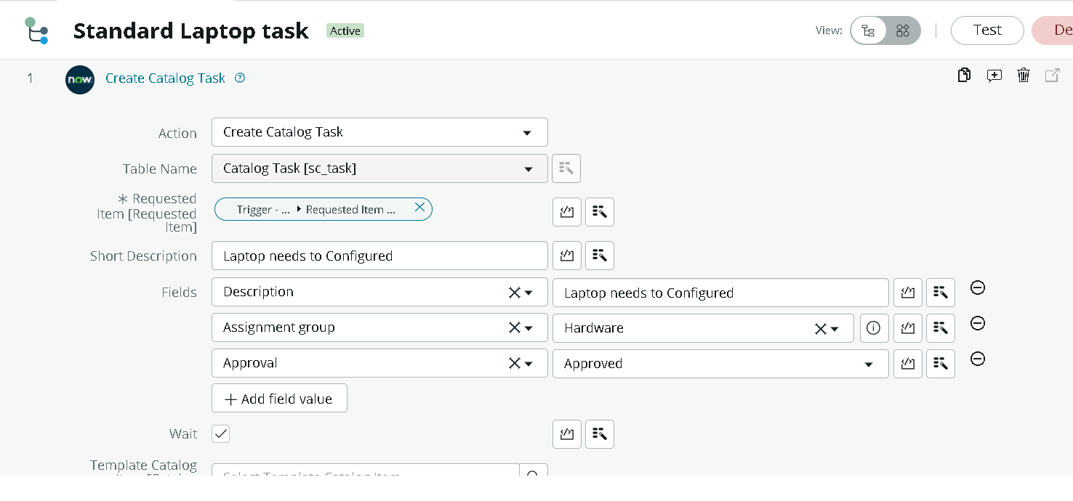  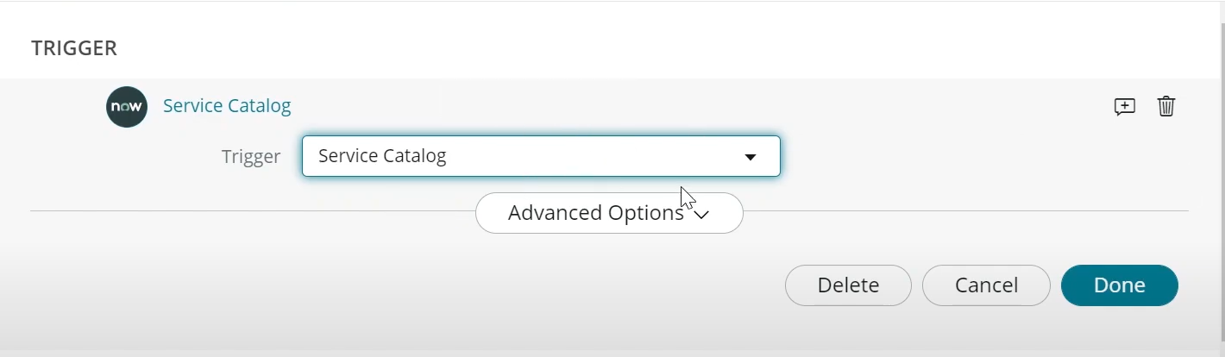
2. | Accuracy | Training Accuracy - N/A  Validation Accuracy - N/A  Not applicable - this is a rule-based ServiceNow Flow Designer automation, not a trained model.  Functional result: test order REQ0010001 -> RITM0010001 -> catalog task SCTASK0010001 was created automatically, assigned to the Hardware group, with the expected short description and Approval = Approved. | 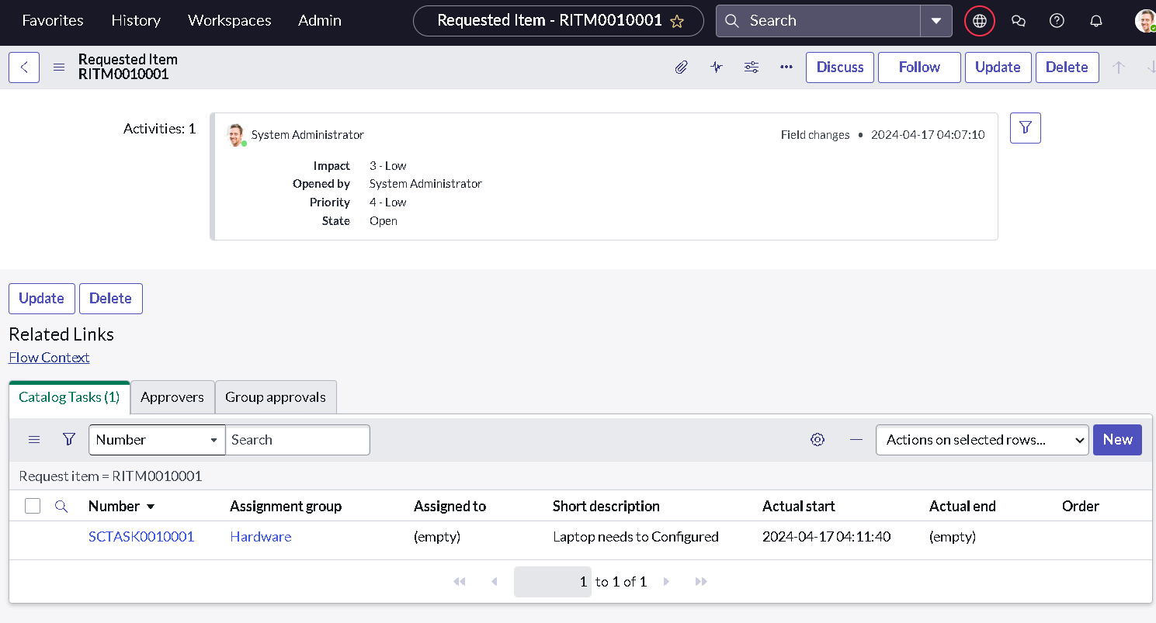
3. | Fine Tunning Result( if Done) | Validation Accuracy - N/A  Not applicable - there is no model to fine-tune. The flow was configured once (Run As: System User, Application: Global) and then saved and activated. | 